**Anthony Dawson,**

**Osman Khan**

**Erick Morales**

**Kevin Vu**

**Component Design**

Component diagram is a diagram that provides a simplified high order view of a large system. In this diagram, we showed the structural relationships between the components of the ATM machine. The three components we have are the ATM, Account, and Operations.

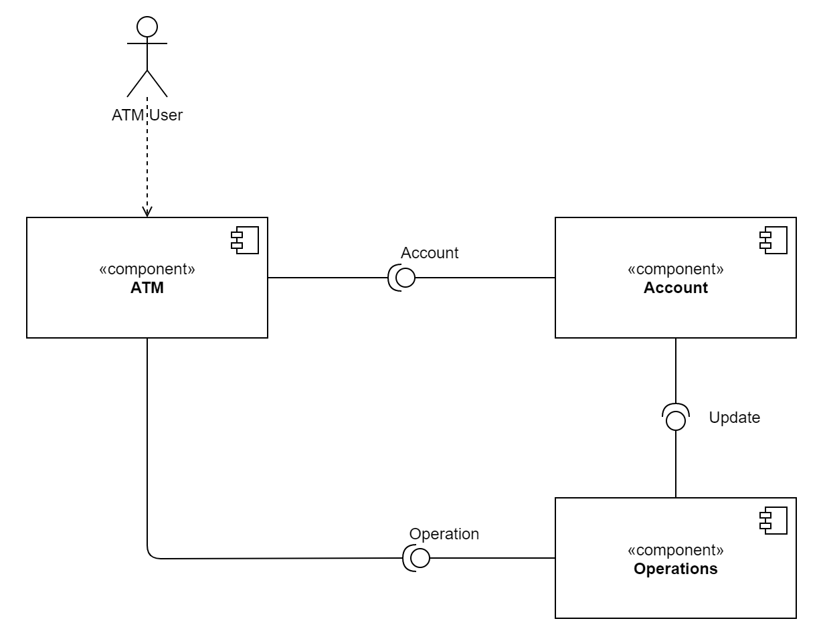

ATM component: ATM and the Menu class.

Account component: Account, Savings, and Checking class

Operations component: Operations, TransferFunds, Deposit, Withdraw, and CheckBalance class